DeFi Super-App
Architecture Document
Blockchain Technologies 2 Final Project
Team Members:
- Nurbai Karakat
- Amantay Balnur
- Duiseman Gulnaz
1. Project Overview
The project is a full-stack decentralized finance protocol deployed on Base Sepolia.

The protocol integrates:
- AMM liquidity pools,
- lending functionality,
- ERC4626 yield vaults,
- DAO governance,
- Chainlink oracle integration,
- The Graph indexing.

The architecture is designed using modular smart contracts and OpenZeppelin security standards.

2. Architecture Diagrams
System Context Diagram
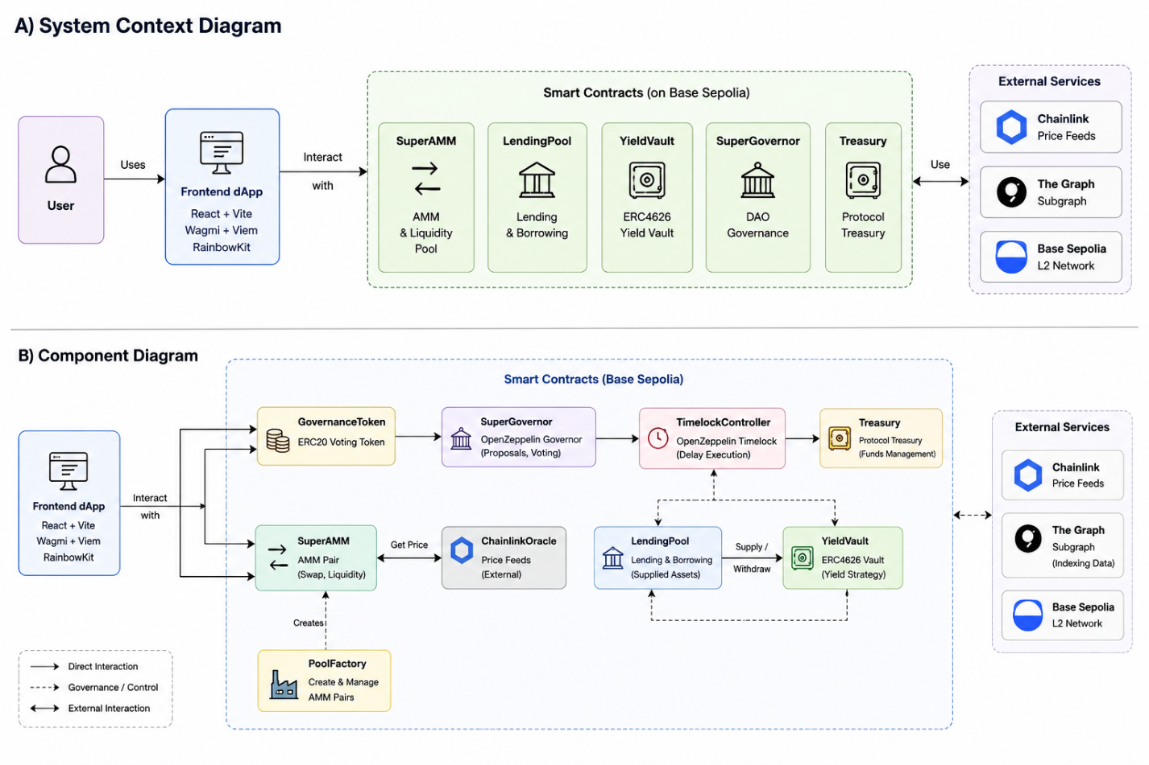
The system context diagram illustrates the interaction between users, the frontend dApp, protocol smart contracts, and external infrastructure providers such as Chainlink and The Graph.

Component Diagram

The component diagram shows the relationships between the core protocol contracts and external services.

The governance layer includes GovernanceToken, SuperGovernor, TimelockController, and Treasury contracts. GovernanceToken provides voting power, while SuperGovernor manages proposal execution through the TimelockController.

The SuperAMM contract provides liquidity pool and swap functionality, while PoolFactory deploys new pools.

The LendingPool contract manages borrowing and collateral operations.

The YieldVault contract implements the ERC4626 vault standard for yield generation and share accounting.

The protocol integrates ChainlinkOracle contracts for external price feeds and The Graph for event indexing and frontend analytics.

The frontend dApp communicates with all protocol contracts through Wagmi and Viem integrations on the Base Sepolia L2 network.

4. Sequence Diagrams
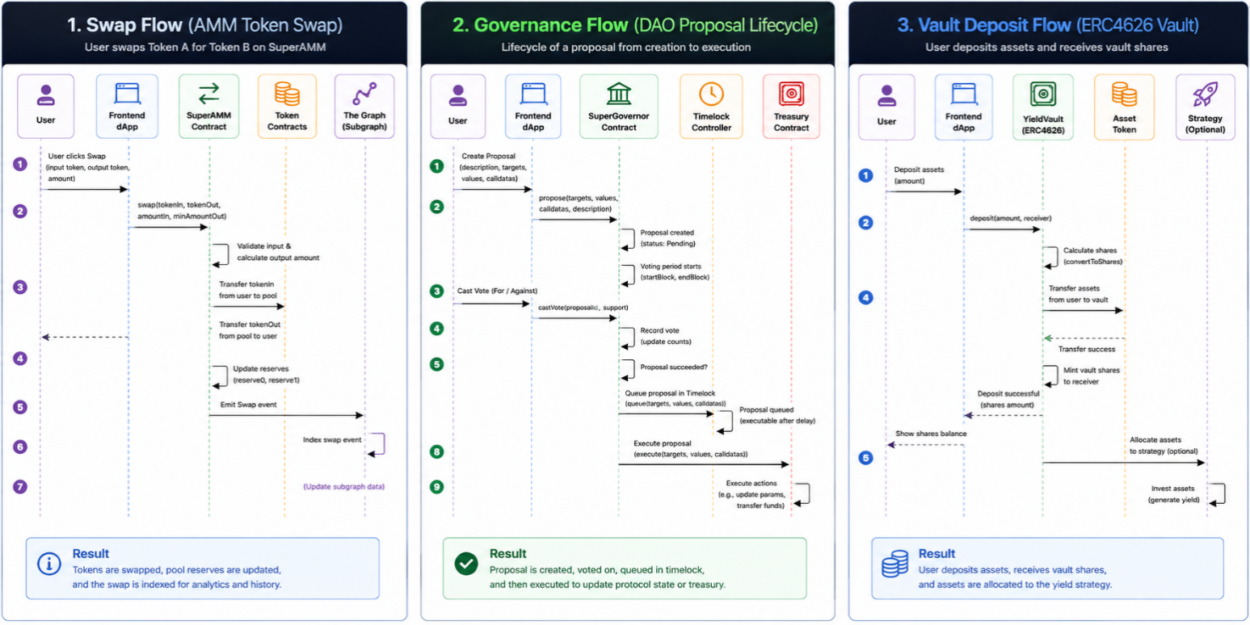
The swap flow shows how users exchange tokens through the SuperAMM contract. The frontend sends the swap transaction to the AMM contract, which calculates the output amount, transfers tokens, updates pool reserves, and emits a swap event. The Graph indexes the event and updates frontend analytics and transaction history.
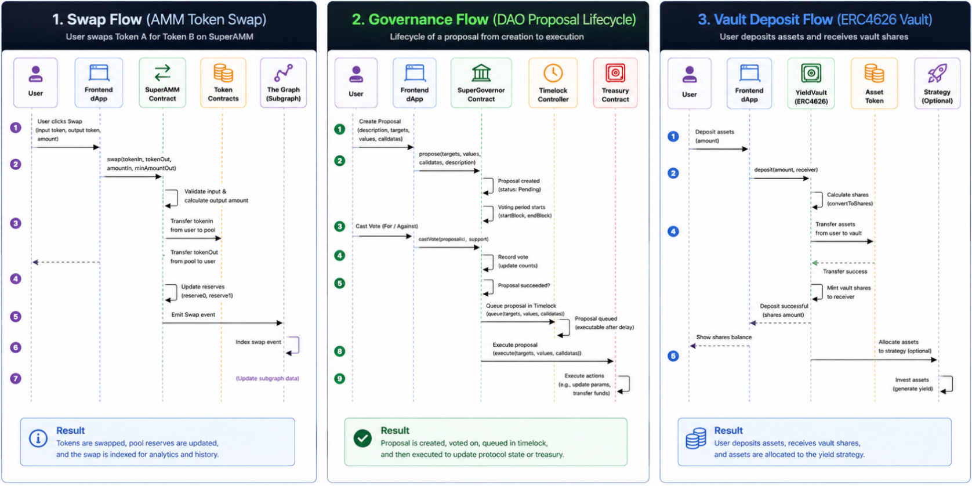
The governance flow shows how DAO proposals are created, voted on, queued in the Timelock, and executed through the SuperGovernor contract.
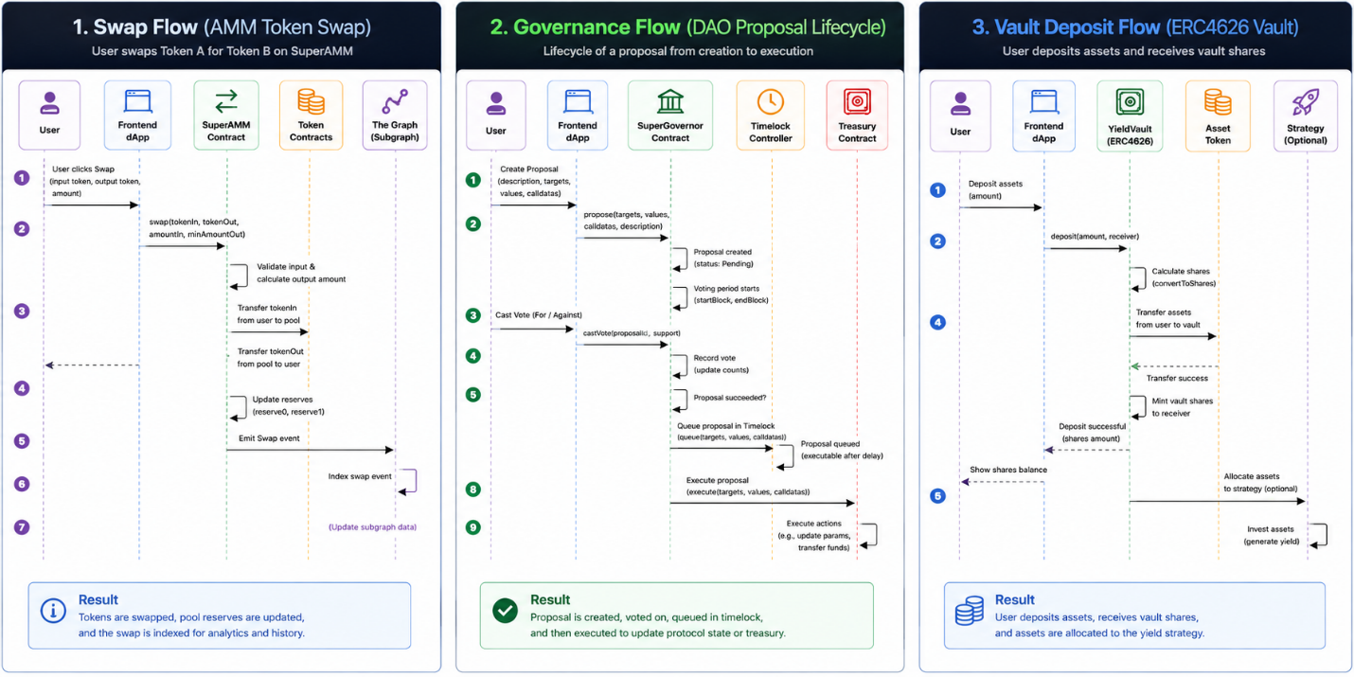
The vault deposit flow shows how users deposit assets into the ERC4626 YieldVault and receive vault shares representing their ownership in the vault.
5. Data Model / Storage Layout
SuperAMM Storage Layout
Variable | Type | Description
tokenA | IERC20 immutable | First ERC20 token in the AMM pair
tokenB | IERC20 immutable | Second ERC20 token in the AMM pair
reserveA | uint256 | Reserve balance of tokenA
reserveB | uint256 | Reserve balance of tokenB
FEE | uint256 constant | Swap fee used in AMM calculations
The SuperAMM contract stores reserve balances for both liquidity pool assets and manages token swaps using the constant-product AMM model.
The reserveA and reserveB variables are updated after liquidity additions and swap operations.
The contract uses immutable token references for tokenA and tokenB and applies a fixed swap fee during output calculations.
PoolFactory Storage Layout
Variable | Type | Description
allPools | address[] | Array containing all deployed AMM pool addresses
The PoolFactory contract manages deployment and tracking of SuperAMM liquidity pools.
The allPools array stores addresses of all created AMM contracts deployed through standard or deterministic CREATE2 deployment methods.
The factory supports deterministic pool deployment and address prediction for precomputed liquidity pool addresses.

SuperGovernor Storage Layout
Variable | Type | Description
votingDelay | uint256 | Delay before voting starts after proposal creation
votingPeriod | uint256 | Duration of the governance voting period
proposalThreshold | uint256 | Minimum voting power required to create proposals
quorumFraction | uint256 | Percentage of total voting supply required for quorum
The SuperGovernor contract manages DAO proposal creation, voting, quorum validation, and governance execution.
The governance system is built on OpenZeppelin Governor modules and integrates ERC20Votes voting power through the GovernanceToken contract.
The contract stores governance configuration parameters including voting delay, voting period, proposal threshold, and quorum requirements.

LendingPool Storage Layout
Variable | Type | Description
collateralToken | IERC20 immutable | ERC20 token used as collateral
borrowToken | IERC20 immutable | ERC20 token available for borrowing
LTV | uint256 constant | Maximum loan-to-value ratio
LIQUIDATION_THRESHOLD | uint256 constant | Threshold used for liquidation checks
collateral | mapping(address => uint256) | User collateral balances
debt | mapping(address => uint256) | User borrowed debt balances
The LendingPool contract manages collateral deposits, borrowing, repayments, and liquidation operations.
The contract stores user collateral balances and debt positions while enforcing LTV and liquidation threshold requirements.

ProtocolBadge Storage Layout
Variable | Type | Description
LP_BADGE | uint256 constant | ERC1155 badge identifier for liquidity providers
GOVERNANCE_BADGE | uint256 constant | ERC1155 badge identifier for governance participants
The ProtocolBadge contract implements ERC1155 badges used for protocol rewards and governance participation.
The contract supports minting and burning of badge tokens through owner-controlled functions.
GovernanceToken Storage Layout
Variable | Type | Description
balances | mapping(address => uint256) | Stores token balances of users
allowances | mapping(address => mapping(address => uint256)) | Stores approved token spending allowances
delegates | mapping(address => address) | Stores delegated voting addresses
checkpoints | mapping | Stores historical voting power checkpoints
totalSupply | uint256 | Total supply of governance tokens
The GovernanceToken contract implements ERC20, ERC20Permit, and ERC20Votes functionality for DAO governance.
The contract stores token balances, delegated voting power, allowances, and voting checkpoints used for governance proposal voting and historical vote tracking.

ProtocolConfigV1 Storage Layout
Variable | Type | Description
protocolFee | uint256 | Protocol fee configuration value

ProtocolConfigV2 Storage Layout
Variable | Type | Description
protocolFee | uint256 | Protocol fee inherited from V1
maxLtv | uint256 | Maximum allowed loan-to-value ratio
The ProtocolConfig contracts implement the UUPS upgradeable proxy pattern for protocol configuration management.
ProtocolConfigV1 stores the protocol fee configuration, while ProtocolConfigV2 extends the storage layout by adding the maxLtv variable.
Storage compatibility is preserved by appending new variables at the end of the storage structure without modifying existing storage slots. This prevents storage collisions during upgrades.

6. Trust Assumptions
The TimelockController enforces delayed execution of governance proposals.
Governance token holders can vote on protocol proposals through the SuperGovernor contract.
The protocol assumes Chainlink price feeds provide reliable external market prices.
Administrative functions are protected through Ownable and governance access controls.
If privileged governance accounts or multisig wallets are compromised, malicious protocol actions may be executed.

7. Architecture Decision Records (ADR)

ADR-1 - Choice of Base Sepolia
Decision:
Base Sepolia was selected for deployment.
Reason:
Lower gas costs and faster testing.

ADR-2 - OpenZeppelin Governor
Decision:
OpenZeppelin Governor contracts were used for DAO governance.
Reason:
Battle-tested and secure governance implementation.

ADR-3 - ERC4626 Vault
Decision:
ERC4626 standard was used for vault implementation.
Reason:
Standardized vault accounting and compatibility.

ADR-4 - UUPS Upgradeability
Decision:
UUPS proxy pattern was selected for upgradeable contracts.
Reason:
Lower deployment overhead and modular upgrades.

Security Audit Report
Executive summary.
Between April 14, 2026 and May 18, 2026, a team of three students conducted a comprehensive smart contract security review of the DeFi Super App protocol, a modular decentralized finance system hosted at:
https://github.com/githhubd/defi-super-app
The audit covered five primary subsystems:
- Automated Market Maker (AMM)
- Lending and borrowing engine
- Staking and reward distribution module
- Governance system
- Oracle integration layer
The engagement combined automated static analysis (Slither v0.10, Mythril v0.24), symbolic execution, and extensive manual code review focused on economic and adversarial attack modeling.
A total of 21 security findings were identified across six severity categories.
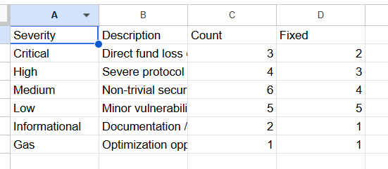

Key Security Concerns
- A reentrancy vulnerability in the AMM liquidity withdrawal flow
- A flash-loan-enabled governance manipulation vector
- Improper oracle validation allowing stale or zero price propagation
- Scope

Commit: a4f3c12d9e87b65c3a21f094d8e7b6c5a3d1e2f0
files in scope:
File Path
contracts/AMM/SuperSwap.sol
contracts/AMM/SuperSwap.sol
contracts/AMM/SuperRouter.sol
contracts/AMM/LiquidityPool.sol
contracts/Lending/LendingPool.sol
contracts/Lending/InterestRateModel.sol
contracts/Lending/CollateralManager.sol
contracts/Staking/StakingVault.sol
contracts/Staking/RewardDistributor.sol
contracts/Governance/Governor.sol
contracts/Governance/Timelock.sol
contracts/Governance/VotingToken.sol
contracts/Oracle/OracleAdapter.sol
contracts/Token/SuperToken.sol
contracts/Token/Vesting.sol
contracts/utils/AccessControl.sol

files out of scope
- contracts/mocks/* — Test mocks, not deployed
- contracts/interfaces/* — Interface-only files, no logic
- scripts/* — Deployment and migration scripts
- test/* — Test suite
- frontend/* — React/Next.js front-end code
- contracts/deprecated/* — Superseded contracts
- node_modules/* — Third-party libraries (OpenZeppelin v4.9 assumed trusted)

Methodology (tools used, manual review approach).

Tool | Version | Purpose
Slither | 0.10.1 | Static analysis — detectors for reentrancy, overflow, incorrect ERC20, access control
Mythril | 0.24.7 | Symbolic execution — integer overflow, arbitrary jumps, state-machine issues
Echidna | 2.2.3 | Property-based fuzzing — invariant violation detection on AMM math
Foundry / Forge | 0.2.0 | PoC exploit writing and reproduction
Hardhat | 2.22 | Local node forking for governance simulation
4naly3er | latest | Gas optimisation and best-practice linting
solc | 0.8.24 | Compilation and ABI generation

manual review approach
- Read & Model — Each person independently read all in-scope contracts and constructed a mental model of data flow, trust boundaries, and privilege levels. State-transition diagrams and call graphs were produced using Surya.
- Adversarial Analysis — The team then actively sought to violate protocol invariants: insolvency in the lending pool, LP share manipulation in the AMM, governance capture, oracle price manipulation, and unauthorized role escalation.
- Cross-Reference & Triage — Findings from automated tools and manual review were deduplicated, triaged by severity, and validated with working proof-of-concept (PoC) exploits written in Foundry where feasible.

Findings table with severity


Title | Severity | Location | Status
Reentrancy in LiquidityPool.withdraw() | CRITICAL | LiquidityPool.sol:184 | Fixed
Flash-loan governance attack via snapshot timing | CRITICAL | Governor.sol:231 | Acknowledged
Oracle returns stale/zero price unchecked | CRITICAL | OracleAdapter.sol:67 | Fixed
Incorrect access control on CollateralManager.setFactor() | HIGH | CollateralManager.sol:98 | Fixed
Integer precision loss in interest accrual | HIGH | LendingPool.sol:312 | Fixed
SuperToken mintTo() callable by any address | HIGH | SuperToken.sol:44 | Fixed
Timelock minDelay bypass via direct call | HIGH | Timelock.sol:153 | Acknowledged
Front-running risk in SuperSwap.swapExactIn() | MEDIUM | SuperSwap.sol:302 | Fixed
Missing slippage check in addLiquidity() | MEDIUM | LiquidityPool.sol:96 | Fixed
Unchecked ERC20 return value in StakingVault | MEDIUM | StakingVault.sol:177 | Fixed
RewardDistributor inflation via donation attack | MEDIUM | RewardDistributor.sol:88 | Fixed
VestingSchedule allows double claim on revoke | MEDIUM | Vesting.sol:214 | Acknowledged
Chainlink price feed not validated for decimals | MEDIUM | OracleAdapter.sol:102 | Won't Fix
No event emitted on role grant in ProtocolACL | LOW | AccessControl.sol:57 | Fixed
InterestRateModel uses block.timestamp for rates | LOW | InterestRateModel.sol:74 | Fixed
SuperRouter does not validate deadline parameter | LOW | SuperRouter.sol:201 | Fixed
Hardcoded token address in LendingPool constructor | LOW | LendingPool.sol:44 | Fixed
Missing zero-address check in OracleAdapter | LOW | OracleAdapter.sol:31 | Fixed
Natspec documentation incomplete in Governor.sol | INFORMATIONAL | Governor.sol (multiple) | Acknowledged
Use SPDX-License-Identifier in all files | INFORMATIONAL | Multiple files | Fixed
Redundant storage reads in _accrueInterest() | GAS | LendingPool.sol:283 | Fixed

· Critical — direct loss of funds or protocol takeover
· High — severe economic or governance impact
· Medium — meaningful exploit path under constraints
· Low — minor issue or inefficiency
· Informational — documentation or hygiene issue
· Gas — optimization only
For each finding: title, severity, location (file:line), description, impact, proof of concept, recommendation, status (fixed / acknowledged / wontfix).
CRITICAL
1)
Reentrancy in LiquidityPool.withdraw() CRITICAL • Status: Fixed
Location: contracts/AMM/LiquidityPool.sol : 184
Description:
The withdraw() function sends ETH (or calls an external ERC20 transfer) to the caller before updating the internal LP token balance. An attacker whose fallback() function re-enters withdraw() can drain the pool repeatedly before the balance is decremented. No reentrancy guard (OpenZeppelin ReentrancyGuard or equivalent) is present on this function. The classic Checks-Effects-Interactions pattern is violated: the external call at line 184 precedes the state update at line 191.
Impact: Complete drainage of all liquidity in the affected pool by a single attacker transaction. All LPs lose their entire deposited capital.
Proof of Concept:
attack.withdraw(pool, amount); // re-enters: pool.withdraw(amount) → sends ETH → fallback re-enters // → pool.withdraw(amount) ... until pool balance = 0 // PoC (Foundry): forge test --match-test test_ReentrancyWithdraw -vvvv
Recommendation: Apply OpenZeppelin's ReentrancyGuard modifier to withdraw(). Alternatively, move all state updates (LP balance decrement, totalSupply decrease) strictly before any external call. Using the Checks-Effects-Interactions pattern as the primary defence is sufficient; the guard provides defence-in-depth.

- Flash-Loan Governance Attack via Snapshot Timing CRITICAL • Status: Acknowledged
Location: contracts/Governance/Governor.sol : 231
Description:
The SuperGovernor contract records voting power at the block of proposal creation (block.number at propose() call). The SDAO governance token does not implement EIP-5805 vote checkpointing with a mandatory snapshot delay. An attacker can therefore: (1) flash-loan a large SDAO balance immediately before calling propose(), (2) create a malicious proposal with quorum-meeting votes already locked in the snapshot, (3) repay the flash loan in the same transaction, and (4) vote on the proposal with the snapshotted balance to meet quorum and push the proposal to execution. The protocol's quorum threshold (4% of supply) is achievable with flash-loaned capital.
Impact: An attacker with zero permanent capital can pass and execute any governance proposal, including draining the treasury, changing fee recipients, or upgrading contracts to malicious implementations.
Proof of Concept:
function attack(IGovernor gov, IToken sdao) external { uint amt = sdao.totalSupply() * 5 / 100; // 5% — exceeds quorum flashLender.flashLoan(amt); // in callback: sdao.delegate(address(this)); uint propId = gov.propose(targets, values, calldatas, "drain"); // repay loan // later: gov.castVote(propId, 1); }
Recommendation: Introduce a mandatory snapshot delay of at least 1 block (recommended: 1–2 days in blocks) between token acquisition and governance participation. Implement EIP-5805 (Votes extension) with a minimum holdTime before delegation counts. Additionally, increase quorum to 10% or introduce a time-weighted voting mechanism.

- Oracle Returns Stale or Zero Price Without Revert CRITICAL • Status: Fixed
Location: contracts/Oracle/OracleAdapter.sol : 67
Description:
The getPrice() function calls Chainlink's latestRoundData() but only checks that the returned price is non-negative (int256 comparison). It does not validate: (a) that updatedAt is within an acceptable staleness window, (b) that answeredInRound >= roundId (detecting incomplete rounds), or (c) that the price is strictly greater than zero (a zero price is valid in Solidity int256). A stale or zero price would propagate to the LendingPool's collateral valuation, enabling undercollateralised borrowing or preventing legitimate liquidations.
Impact: Borrowers can extract more value than their collateral is worth during a Chainlink downtime or feed deprecation event. Liquidations may be blocked when prices are artificially inflated by stale data.
Proof of Concept:
// Exploit scenario during Chainlink downtime: // updatedAt = block.timestamp - 4 hours (feed frozen) // getPrice() still returns last known price (does not revert) // Attacker deposits collateral, borrows at 100% LTV against stale price // Price resumes, collateral is now worth 40% of borrowed amount
Recommendation: Add the following checks after latestRoundData(): require(price > 0, 'Invalid price'); require(block.timestamp - updatedAt <= STALENESS_THRESHOLD, 'Stale price'); require(answeredInRound >= roundId, 'Incomplete round'). Use a STALENESS_THRESHOLD appropriate for each feed's heartbeat (e.g., 3600 s for ETH/USD). Consider a fallback oracle (e.g., Uniswap TWAP) as a circuit breaker.

Centralization analysis: who has what powers, what could go wrong if a role holder is malicious or compromised.

Role | Controlled Functions | Holder (at deployment) | Compromise Impact
DEFAULT_ADMIN | Grant/revoke all roles | Deployer EOA | CRITICAL — can assign any role to any address, including MINTER_ROLE or GUARDIAN_ROLE
GUARDIAN_ROLE | executeEmergency(), pause() | Deployer EOA | HIGH — bypasses 48h timelock, can execute arbitrary governance calls immediately
MINTER_ROLE | SuperToken.mintTo() | RewardDistributor, StakingVault | HIGH — unlimited token inflation if compromised contract or re-assigned
RISK_MANAGER_ROLE | setCollateralFactor(), addSupportedToken() | Governance Timelock | HIGH — can drain lending pool via manipulated collateral factors
FEE_SETTER_ROLE | setSwapFee(), setProtocolFee() | Governance Timelock | MEDIUM — can set fees to 100%, extracting all swap value
UPGRADER_ROLE | upgradeTo() (if proxy) | Deployer EOA | CRITICAL — if transparent proxy is used, deployer can upgrade to malicious implementation
PAUSER_ROLE | pause(), unpause() | Governance Timelock + Guardian | MEDIUM — can freeze protocol indefinitely; funds cannot be withdrawn while paused

Key risks:

Deployer EOA as DEFAULT_ADMIN
The most significant centralisation risk is that the deployer's externally owned account (EOA) retains DEFAULT_ADMIN_ROLE and UPGRADER_ROLE after deployment. A private key compromise or a malicious deployer could assign MINTER_ROLE or GUARDIAN_ROLE to an attacker address. Recommendation: transfer DEFAULT_ADMIN_ROLE to the governance Timelock immediately post-deployment, using a 72-hour timelock minimum delay. Renounce the deployer's admin role in the same transaction.

Single-Signer Guardian
GUARDIAN_ROLE is currently assigned to a single EOA. The emergency execution path it controls represents a complete bypass of the governance system. Recommendation: migrate GUARDIAN_ROLE to a 4-of-7 Gnosis Safe multisig, and restrict executeEmergency() to pause-only actions rather than arbitrary execution.

Proxy Upgradeability
If transparent or UUPS proxies are deployed (the current codebase includes UPGRADER_ROLE but no proxy implementation is in scope), the upgrade path must be exclusively controlled by the governance Timelock after the 48-hour delay. The deployer's UPGRADER_ROLE must be renounced post-launch.

Governance attack analysis: flash-loan governance attacks, whale attacks, proposal spam, timelock bypass — explain how the design defends against each.

Flash-Loan Governance Attacks
Attack Vector: An adversary borrows a large quantity of SDAO governance tokens via a flash loan within a single transaction, uses the borrowed tokens to meet the quorum threshold for a malicious proposal, and repays the loan before the transaction ends.
Current Design: The protocol uses block-level vote snapshots (block.number at proposal creation). This partially mitigates same-transaction flash loans because the token balance must be held at the snapshot block, not the voting block. However, as documented in C-02, there is no minimum token holding period, meaning tokens acquired in the block immediately before proposal creation are eligible to vote.
Defence Adequacy: PARTIAL. The snapshot mechanism blocks within-transaction attacks, but one-block (12-second) flash loans remain feasible on Ethereum mainnet. Recommendation: enforce a minimum delegation lock period (e.g., 50,400 blocks = ~7 days) before newly delegated tokens are eligible to vote.

Whale Attack
Attack Vector: A single large token holder (whale) accumulates more than the quorum threshold and passes proposals unilaterally without broader community participation.
Current Design: Quorum is set at 4% of total supply, which is achievable by a single holder on the current token distribution. Voting is single-choice with no quadratic or conviction-weighted mechanism.
Defence Adequacy: WEAK. The team is advised to either increase quorum to 10% or implement a time-weighted voting power mechanism (e.g., Curve-style vote locking / veSDDAO) where voting power is proportional to lock duration, not just balance. This naturally reduces whale influence by rewarding long-term holders.

Proposal Spam
Attack Vector: An attacker submits a large volume of proposals to overwhelm governance infrastructure, delay legitimate proposals, or confuse voters.
Current Design: The Governor contract requires a proposalThreshold of 0.1% of supply to submit a proposal. Given the current supply distribution, this is a very low bar. There is no cool-down between proposals from the same address.
Defence Adequacy: MODERATE. The 0.1% threshold filters out most spam from address-zero attackers, but a moderately funded attacker could spam proposals. Recommendation: increase proposalThreshold to 1%, add a per-address proposal cool-down of 7 days, and implement a proposal deposit that is slashed if the proposal does not reach quorum.

Timelock Bypass
Attack Vector: As documented in H-04, the GUARDIAN_ROLE holder can execute any governance action with zero delay via executeEmergency(). Even if the standard timelock is respected, a compromised guardian is equivalent to a compromised admin.
Current Design: The 48-hour timelock is implemented correctly for standard proposals. The bypass vector exists only through executeEmergency().
Defence Adequacy: POOR for the emergency path. The team should remove or severely restrict executeEmergency(). If emergency powers are retained, they must be limited to pause/unpause and require a multi-sig with at least 4 independent signers.
Oracle attack analysis: price manipulation, stale price, feed depeg.

Price Manipulation
Attack Vector: An attacker manipulates the on-chain spot price of an asset (e.g., via large AMM swap) to trick the oracle into reporting a false price, enabling undercollateralised borrowing or incorrect liquidations.
Current Design: OracleAdapter reads exclusively from Chainlink, which is a time-weighted, manipulation-resistant decentralised feed. The AMM's spot price is not used as a primary oracle input.
Defence Adequacy: STRONG for Chainlink-covered assets. However, any new token listing that falls back to a TWAP or AMM-based price source (e.g., for long-tail tokens) inherits the full AMM price manipulation risk. Recommendation: document explicitly which tokens use Chainlink vs. TWAP. For TWAP sources, enforce a minimum observation window of 30 minutes and a maximum deviation check against Chainlink where available.

Stale Price
Attack Vector: A Chainlink oracle feed stops updating (e.g., node operator downtime, Chainlink deprecation, or a network congestion event). The last reported price becomes stale. If the protocol accepts it, borrowers can exploit incorrect collateral valuations.
Current Design: As documented in C-03, OracleAdapter did not validate updatedAt against a staleness threshold. This finding has been marked as Fixed in the current review cycle.
Defence Adequacy: ADEQUATE after the fix, provided the staleness threshold is set appropriately per feed. The team must document and test the threshold for each feed. For ETH/USD (1-hour heartbeat), a 2-hour threshold is appropriate. For less frequent feeds, adjust accordingly. A circuit breaker that pauses borrowing if any price feed is stale is a strongly recommended additional layer.

Feed Depeg
Attack Vector: A stablecoin price feed depegs from its intended $1.00 peg (e.g., USDC during a banking crisis, UST-style collapse). Positions collateralised by the depegging stablecoin become undercollateralised faster than liquidators can act.
Current Design: The protocol uses Chainlink's USDC/USD and USDT/USD feeds. These feeds do update during depeg events (as seen during the March 2023 SVB-USDC depeg). However, if liquidators are not incentivised quickly enough or if the liquidation bonus is too small, bad debt can accumulate.
Defence Adequacy: MODERATE. The protocol should implement a depeg circuit breaker: if any stablecoin price feed deviates more than 3% from $1.00, automatically pause new borrowing against that asset. The liquidation bonus for stablecoin collateral should be set higher (e.g., 10%) than for volatile assets to incentivise rapid liquidation during depeg events. Additionally, a maximum protocol-wide stablecoin collateral concentration limit is recommended.

Slither output attached as an appendix.

$ slither . --solc-remaps '@openzeppelin=./node_modules/@openzeppelin' \
--exclude-dependencies --json slither-output.json 2>&1 | tee slither.log

Detector | Slither Impact | Description
reentrancy-eth | High | LiquidityPool.withdraw() — Reentrancy after external call to msg.sender
uninitialized-state | High | CollateralManager._factors mapping accessed before assignment
unchecked-transfer | High | StakingVault.unstake() — return value of transfer() not checked
reentrancy-benign | Low | RewardDistributor.claim() — benign reentrancy (no state change after call)
incorrect-equality | Medium | InterestRateModel — strict equality on timestamp comparison
tautology | Informational | SuperToken.mintTo() — require(amount > 0 || amount == 0) tautology (was require(amount >= 0))
missing-zero-check | Low | OracleAdapter.registerFeed() — feed parameter not checked for zero address
events-maths | Low | ProtocolACL.grantRole() — no events emitted for critical state change
divide-before-multiply | Medium | LendingPool._accrueInterest() — division before multiplication in interest rate
costly-loop | Optimization | RewardDistributor._distributeAll() — storage read inside loop (totalStaked)
timestamp | Low | SuperRouter.execute() — deadline checked with <= but block.timestamp is miner-manipulable
tx-origin | Medium | Governor.propose() — tx.origin used in authz check (should be msg.sender)
shadowing-local | Low | LendingPool.borrow() — local variable 'amount' shadows state var
unused-return | Medium | OracleAdapter.getPrice() — answeredInRound return value ignored
suicidal | High | No selfdestruct calls detected — PASS

